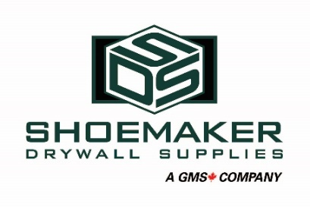
Account Manager
Shoemaker Drywall Supplies is looking for a motivated sales professional to fill the role of Account Manager. As a proven leader in our industry, Shoemaker focuses on core products such as drywall, insulation, steel studs, roofing products and ceiling systems. As a division of GMS Canada, a publicly traded company operating throughout North America, our focus is on the Western Canadian market covering Manitoba to British Columbia. This position is located at our office in Regina, SK.
This position will be responsible for all sales activities from lead generation to bid closure within the assigned territory. Customer satisfaction, increased revenue generation, and business development initiatives which align with our vision and values are the primary responsibilities.
Key Responsibilities:
- Manage an established account base to meet targets
- Identify and secure new opportunities for sales within the territory for all product areas
- Effectively build and maintain client relationships
- Maintain regular client call schedules and in-person communication
- Complete professional client proposals following company pricing structures
- Work with vendors to ensure quote accuracy including costing and timeline accountability
- Develop quarterly stretch target strategies while reacting to constantly changing market conditions
- Work with product, marketing, and operations teams to deliver solutions that meet client needs
- Stay up to date with market developments and trends, product applications and opportunities
- Participate in industry and client trade shows and conventions
- Conduct client presentations when required
- Ensure project tracking is up to date and monitored, completing weekly sales reports as necessary
- Travel will be required in this role
Position Requirements:
- Post-Secondary Degree in Business or Marketing preferred
- Minimum 3 years of sales experience
- Previous building materials industry experience an asset
- Fundamental understanding of specifications and drawings
- Strong communication and interpersonal skills with the ability to interact with personnel at all levels
- Proven ability to develop and foster strong relationships with customers and vendors
- Exceptional problem solving and negotiation skills
- Strong time management and organization
- Ability to perform under pressure in a fast-paced environment
Apply to HR with your resume and cover letter

